CS 305 Project One Template

Document Revision History

Version | Date | Author | Comments
1.0 | March 16, 2026 | Samuel Raymond Kwibe

Client



Instructions
Submit this completed vulnerability assessment report. Replace the bracketed text with the relevant information. In this report, identify your security vulnerability findings and recommend the next steps to remedy the issues you have found.

- Respond to the five steps outlined below and include your findings.
- Respond using your own words. You may also include images or supporting materials. If you include them, make certain to insert them in the relevant locations in the document.
- Refer to the Project One Guidelines and Rubric for more detailed instructions about each section of the template.

Developer
Samuel Raymond Kwibe

1. Interpreting Client Needs
Determine your client’s needs and potential threats and attacks associated with the company’s application and software security requirements. Consider the following questions regarding how companies protect against external threats based on the scenario information:

- What is the value of secure communications to the company?
- Are there any international transactions that the company produces?
- Are there governmental restrictions on secure communications to consider?
- What external threats might be present now and in the immediate future?
- What modernization requirements must be considered, such as the role of open-source libraries and evolving web application technologies?

Value of Secure Communications
Value of Secure Communications: Artemis Financial works with people's most sensitive financial data — savings, retirement plans, investments, and insurance. That kind of information is extremely valuable to attackers, and if it ever gets leaked or stolen, the damage goes way beyond just fixing a technical problem. The company could face lawsuits, government fines, and the kind of reputation damage that is very hard to come back from. More than that, clients trust Artemis Financial with their financial futures, and that trust depends entirely on knowing their data is safe. Encrypting data in transit and at rest, enforcing HTTPS, and securing all API endpoints are not just best practices here — they are the minimum standard for any financial company operating today.

International Transactions and Government Restrictions: The scenario tells us that Artemis Financial serves entrepreneurs, businesses, and government agencies around the world. That means data is crossing borders, and that brings in a whole set of legal requirements that the company has to be aware of. Below are the key regulations that apply:
- GDPR (European Union): Protects EU residents' personal data. Requires user consent, limits on data collection, and breach notification within 72 hours.
- CCPA (California): Gives California residents the right to know what data is collected about them and the right to opt out of its sale.
- GLBA (Gramm-Leach-Bliley Act): US federal law requiring financial institutions to keep customer financial information secure and confidential.
- PCI DSS: Applies any time the application processes payment card data. Requires encryption, access controls, and regular security audits.
- SOX (Sarbanes-Oxley): May apply if Artemis Financial serves publicly traded clients, requiring that financial records are secure, accurate, and auditable.

External Threats: After reviewing the code base, I identified several real threats that Artemis Financial is exposed to right now, not just hypothetically:
- SQL Injection: The database connection in DocData.java does not use parameterized queries, so an attacker could manipulate inputs to access or destroy the entire database.
- Unauthorized Access: Every single REST endpoint in the application is completely open with no login or token required. Anyone who finds the URL can call the API.
- Credential Theft: The database username and password are hardcoded directly in the source code as "root" and "root". Anyone with access to the code has full database access.
- Dependency Exploits: The project uses Spring Boot 2.2.4 and Bouncy Castle 1.46, both of which have published critical CVEs that attackers can look up and exploit.
- Denial-of-Service: The application accepts file uploads up to 200 MB with no file type validation, making it easy to flood the server and take it offline.

Modernization Requirements: There are two areas that stand out when thinking about modernizing this application. First, it relies heavily on open-source libraries like Spring Boot, Bouncy Castle, and JSON Path. Open-source is great, but every vulnerability found in those libraries gets published publicly, which means attackers know about them too. The fix is to integrate OWASP Dependency-Check directly into the Maven build so every build automatically catches outdated dependencies before they make it to production. Second, the API itself needs to be brought up to modern standards. That means enforcing HTTPS on all endpoints, requiring token-based authentication like JWT or OAuth 2.0, and validating every input that comes in from outside. These are not advanced features — they are the baseline for any web-facing API that handles financial data.

International Transactions
Based on the scenario, Artemis Financial works with clients and agencies around the world, which means the company likely handles transactions and data that cross international borders. This introduces legal requirements from multiple countries and regions that the company has to follow. Some of the key regulations to consider are:
- GDPR (European Union): This law requires companies to protect personal data of EU residents, get user consent before collecting data, and report breaches within 72 hours.
- CCPA (California): Requires companies to disclose how they collect and use data for California residents and allows residents to opt out.
- GLBA (Gramm-Leach-Bliley Act): A US federal law that requires financial companies to protect customers' private financial information.
- PCI DSS: Applies if Artemis Financial ever processes payment card data, requiring strong encryption and access controls.
- SOX (Sarbanes-Oxley): Could apply if the company works with publicly traded clients, requiring secure and auditable financial records.

External Threats
Looking at the current code base, there are several threats that Artemis Financial needs to be aware of right now, as well as threats that will only grow more serious in the future:
- SQL Injection: The application connects to a database without using parameterized queries, which means an attacker could manipulate the input to access or destroy data.
- Unauthorized Access: None of the API endpoints require any login or authentication, so anyone who finds the URL can call them freely.
- Credential Theft: Database credentials are hardcoded directly in the source code, so anyone who gets access to the code gets access to the database.
- Dependency Exploits: The project uses outdated libraries with known critical vulnerabilities that attackers can look up and exploit.
- Denial-of-Service: The application accepts file uploads up to 200 MB with no restrictions, which could easily be abused to crash the server.

Modernization Requirements
There are two modernization areas that stand out here. First, the project relies on open-source libraries like Spring Boot, Bouncy Castle, and JSON Path. Open-source software is very useful but it also needs to be kept up to date, since vulnerabilities in those libraries get published publicly for anyone to see. Integrating a tool like OWASP Dependency-Check into the build process helps catch these issues early. Second, as a RESTful API, the application needs to follow modern web security practices like using HTTPS for all communication, requiring authentication tokens for API access, and validating all user input. These are not optional extras, they are the baseline expectation for any web-facing financial application today.

2. Areas of Security
Refer to the vulnerability assessment process flow diagram. Identify which areas of security apply to Artemis Financial’s software application. Justify your reasoning for why each area is relevant to the software application.

After going through the vulnerability assessment process flow diagram and reading through every source file in the project, I found that all seven security areas from the diagram are relevant to this application. Here is my reasoning for each one:

Security Area | Applicable? | Why It Applies to This Application
Input Validation | YES | The /read endpoint takes a business_name parameter directly with no length check, character validation, or sanitization. This is exactly the kind of unguarded input that leads to injection attacks. Any application accepting external data must validate it before using it.
Authentication and Authorization | YES | Neither /read nor /greeting requires any kind of login, token, or API key. Anyone who discovers these URLs can call them freely. For a financial application this is a critical gap that needs to be addressed before the app goes anywhere near production.
Cryptography | YES | The project pulls in Bouncy Castle 1.46, a cryptography library from 2011. Multiple high-severity CVEs exist against this version targeting its encryption implementations. Since the application deals with financial data, weak or broken cryptography is a serious risk.
Known Vulnerabilities | YES | Both Spring Boot 2.2.4 and Bouncy Castle 1.46 have well-documented CVEs in the NIST National Vulnerability Database. Spring Boot 2.2.4 alone carries the critical Spring4Shell vulnerability (CVE-2022-22965). These need to be updated immediately.
Data Encapsulation | YES | In customer.java, the account_balance field has no access modifier at all, making it package-private by default. This means any class in the same package can read or modify it directly. Financial data like an account balance must be private and protected by controlled methods.
Error Handling | YES | DocData.java catches database exceptions and calls e.printStackTrace(), which dumps the full stack trace including class names, file paths, and library versions to the console. In production that information could be visible to an attacker and help them map out the system.
Code Quality | YES | Two class names (customer and myDateTime) violate Java naming conventions. Several methods are empty stubs that do nothing. There is no input validation anywhere. These issues make the code fragile and hard to maintain, and they increase the chance of security defects being introduced as the code grows.

Dependency | CVE Code(s) | Severity | Description | Recommended Fix | Attribution (CVE References section)
bcprov-jdk15on-1.46  (Bouncy Castle) | CVE-2020-15522  CVE-2020-26939  CVE-2018-1000613  CVE-2016-1000338 | HIGH /  CRITICAL | Bouncy Castle 1.46 has multiple cryptographic flaws. CVE-2020-15522 is a timing side-channel on ECDSA that can expose private keys. CVE-2020-26939 is a CBC padding oracle. Both were disclosed by the Bouncy Castle team and published in the NVD. | Upgrade to Bouncy Castle 1.77 or newer. The CVE-2020-15522 References section links to the release page confirming 1.66 as the first patched version. Review all crypto operations after upgrading. | NVD: nvd.nist.gov/vuln/detail/CVE-2020-15522  Fix: bouncycastle.org/latest_releases.html  GitHub: github.com/bcgit/bc-java/releases
spring-boot-2.2.4  (Spring Framework  + Tomcat) | CVE-2022-22965  (Spring4Shell)  CVE-2021-22096  CVE-2020-5421  CVE-2023-46589 | CRITICAL /  HIGH | CVE-2022-22965 (Spring4Shell) allows unauthenticated remote code execution on JDK 9+ via class loader manipulation. It was widely exploited in 2022. Other CVEs affect HTTP request smuggling and input validation bypass. | Upgrade to Spring Boot 3.2.x. The CVE-2022-22965 References section links to the official Spring security advisory at spring.io/security/cve-2022-22965. Java 17+ is required for Spring Boot 3. | NVD: nvd.nist.gov/vuln/detail/CVE-2022-22965  Spring advisory: spring.io/security/cve-2022-22965  VMware: tanzu.vmware.com/security/cve-2022-22965
json-path  (version not pinned) | CVE-2023-51074 | MEDIUM | json-path versions before 2.9.0 crash on deeply nested path expressions due to a stack overflow. This can be triggered by a crafted API request to cause denial of service. | Explicitly pin json-path to 2.9.0 or later in pom.xml. The CVE-2023-51074 References section links to the GitHub pull request (PR #973) that introduced the fix. | NVD: nvd.nist.gov/vuln/detail/CVE-2023-51074  GitHub fix: github.com/json-path/JsonPath/pull/973  Release: github.com/json-path/JsonPath/releases/tag/json-path-2.9.0
Embedded Tomcat  (via Spring Boot  2.2.4) | CVE-2023-28708  CVE-2023-46589 | HIGH | CVE-2023-28708 leaks session cookie attributes via partial PUT requests. CVE-2023-46589 enables HTTP request smuggling. Both were reported by the Apache Tomcat security team and are present in the Tomcat version bundled with Spring Boot 2.2.4. | Upgrading to Spring Boot 3.2.x automatically pulls in Tomcat 10.1.x which fixes both issues. The CVE References sections both link to the Apache Tomcat security announcements page. | NVD: nvd.nist.gov/vuln/detail/CVE-2023-28708  NVD: nvd.nist.gov/vuln/detail/CVE-2023-46589  Apache: tomcat.apache.org/security-10.html

3. Manual Review
Continue working through the vulnerability assessment process flow diagram. Identify all vulnerabilities in the code base by manually inspecting the code.

I went through every source file in the project one by one and looked for security issues. I was specifically looking for places where user input flows directly into sensitive operations, where sensitive data is exposed, and where the code does things that could cause problems at runtime. I found twelve vulnerabilities in total. Here is what I found:

# | File | Vulnerability | Description
1 | DocData.java | Hardcoded Database Credentials | Lines 18-19 hardcode the database username as "root" and password as "root" directly in the source code. Anyone who can read the code has full database access. Credentials cannot be rotated without editing and redeploying the application.
2 | DocData.java | SQL Injection Risk | The read_document() method accepts key and value parameters that are never used in a parameterized query. If the method is completed using string concatenation, an attacker could inject SQL to read, modify, or delete the entire database.
3 | DocData.java | Information Disclosure via Stack Trace | Exceptions are handled with e.printStackTrace(), which prints class names, file paths, and library versions to the console. In production, this output leaks internal system details that attackers can use to plan more targeted attacks.
4 | DocData.java | No SSL on Database Connection | The JDBC URL jdbc:mysql://localhost:3306/test has no SSL configured. All data between the application and database travels in plain text and can be intercepted by anyone on the same network.
5 | CRUDController.java | No Authentication on /read Endpoint | The /read endpoint has no authentication, authorization, or access control of any kind. Any caller who knows the URL gets a response. This is completely unacceptable for a financial API.
6 | CRUDController.java | No Input Validation on business_name | The business_name parameter from the URL is passed straight to DocData with no length limit, character filtering, or format check. This opens the door for injection attacks and unexpected application behavior.
7 | customer.java | account_balance is Package-Private | The account_balance field has no access modifier, making it package-private. Any class in the package can directly read or modify a customer's balance. Sensitive financial fields must be declared private.
8 | customer.java | Integer Overflow in deposit() | The deposit() method adds a to account_balance with no overflow check. If the result exceeds Integer.MAX_VALUE, the balance silently wraps around to a large negative number. In a financial application this is a critical defect.
9 | myDateTime.java | Unimplemented Stub Methods | retrieveDateTime() returns an empty int array and setMyDateTime() does nothing at all. Deploying code with empty stub methods causes silent failures and unpredictable behavior when those methods are called at runtime.
10 | application.properties | Unrestricted File Upload Size | max-file-size is 200 MB with no file type validation. An attacker can repeatedly upload oversized files to exhaust server memory and disk space, causing a denial-of-service condition.
11 | pom.xml | Outdated Spring Boot (2.2.4.RELEASE) | Spring Boot 2.2.4 bundles an outdated Spring Framework and embedded Tomcat. The most critical issue is CVE-2022-22965 (Spring4Shell) — an unauthenticated remote code execution vulnerability on JDK 9+. This version is actively exploited.
12 | pom.xml | Outdated Bouncy Castle (1.46) | Bouncy Castle 1.46 is from 2011 and has multiple high-severity CVEs. CVE-2020-15522 allows a timing attack to recover private ECDSA keys. CVE-2020-26939 is a CBC padding oracle attack. Both compromise the confidentiality of encrypted data.

Priority | Issue | File(s) | How to Fix It
CRITICAL | Hardcoded database credentials | DocData.java | Remove the hardcoded root credentials immediately. Move database connection details to environment variables or a secrets manager like HashiCorp Vault. Create a dedicated database user with only the permissions the application actually needs.
CRITICAL | Spring4Shell — Spring Boot 2.2.4 | pom.xml | Upgrade the Spring Boot parent to the latest 3.2.x release. This automatically upgrades Spring Framework and embedded Tomcat to patched versions. The project will also need to move to Java 17 or higher. The official Spring security advisory (CVE-2022-22965 References) confirms the minimum safe versions.
CRITICAL | Bouncy Castle 1.46 cryptographic CVEs | pom.xml | Update bcprov-jdk15on to version 1.77 or newer. The Bouncy Castle release page linked in the CVE-2020-15522 References section confirms 1.66 was the first patched release. After upgrading, audit all cryptographic operations in the codebase.
HIGH | No authentication on REST endpoints | CRUDController.java | Add Spring Security and configure JWT Bearer Token or OAuth 2.0 authentication on all endpoints. Add role-based access control so users can only access what they are authorized to see.
HIGH | SQL injection in read_document() | DocData.java | Rewrite read_document() to use PreparedStatement with parameterized queries. Even better, migrate to Spring Data JPA which handles safe parameterization automatically and reduces the chance of this kind of mistake.
HIGH | No SSL on database connection | DocData.java | Add ?useSSL=true&requireSSL=true to the JDBC URL. Configure the database server to require TLS. Store certificate and keystore credentials in a secrets manager, never in source code.
HIGH | Stack trace exposed in logs | DocData.java | Replace e.printStackTrace() with SLF4J logging: logger.error("message", e). Spring Boot already includes SLF4J. Configure log output to go to a secure log file at ERROR level only, never to the console in production.
HIGH | 200 MB unrestricted file uploads | application.properties | Lower max-file-size to a reasonable limit like 10 MB. Add file type validation using MIME type checking to reject unexpected file formats. Add rate limiting on the upload endpoint to prevent abuse.
MEDIUM | No input validation on request params | CRUDController.java | Add @NotBlank, @Size, and @Pattern annotations to all request parameters. Create a @ControllerAdvice global exception handler that returns clean, structured error responses without leaking internal details.
MEDIUM | account_balance is package-private | customer.java | Declare account_balance as private. Add a getAccountBalance() getter and update the deposit() method to reject negative values and validate the input before updating the balance.
MEDIUM | Integer overflow in deposit() | customer.java | Replace the raw addition with Math.addExact(account_balance, a) which throws an ArithmeticException on overflow instead of silently corrupting the balance. Consider using long instead of int for financial values.
LOW | Unimplemented stub methods | myDateTime.java | Either implement retrieveDateTime() and setMyDateTime() with real logic, or remove the class entirely if it is not used. Shipping empty stubs causes confusing silent failures at runtime.
LOW | Class naming conventions violated | customer.java,  myDateTime.java | Rename customer to Customer and myDateTime to MyDateTime to follow standard Java naming conventions. This prevents class-loading issues on case-sensitive Linux file systems and improves code readability.
LOW | Dependency-Check plugin outdated | pom.xml | The plugin was updated to 10.0.4 for this assessment. Keep it at the latest version going forward so every build scans against the most current CVE data from the NVD.

4. Static Testing
Run a dependency check on Artemis Financial’s software application to identify all security vulnerabilities in the code. Record the output from the dependency-check report. Include the following items:

- The names or vulnerability codes of the known vulnerabilities
- A brief description and recommended solutions provided by the dependency-check report
- Any attribution that documents how this vulnerability has been identified or documented previously

To run the static test I updated the OWASP Dependency-Check Maven plugin in pom.xml to version 10.0.4 and added my NVD API key so it could connect to the NIST National Vulnerability Database. When I ran Maven install, the plugin downloaded 338,260 CVE records and scanned all project dependencies. The results were saved to target/dependency-check-report.html. The console screenshots below show the execution and the BUILD SUCCESS confirmation.

For each vulnerability I found, I went to https://nvd.nist.gov and searched the CVE code directly. I used the References section at the bottom of each CVE entry, which links to the actual fix, the patched release, or the official security advisory. Those reference links are in the Attribution column below.

The following table summarizes the key vulnerabilities found by the dependency-check report. All CVE records listed below are documented in the NIST National Vulnerability Database at https://nvd.nist.gov and in the OWASP Dependency-Check project at https://jeremylong.github.io/DependencyCheck/.

Figure 1: Eclipse Console — dependency-check:10.0.4 starting, NVD API has 338,260 records in this update

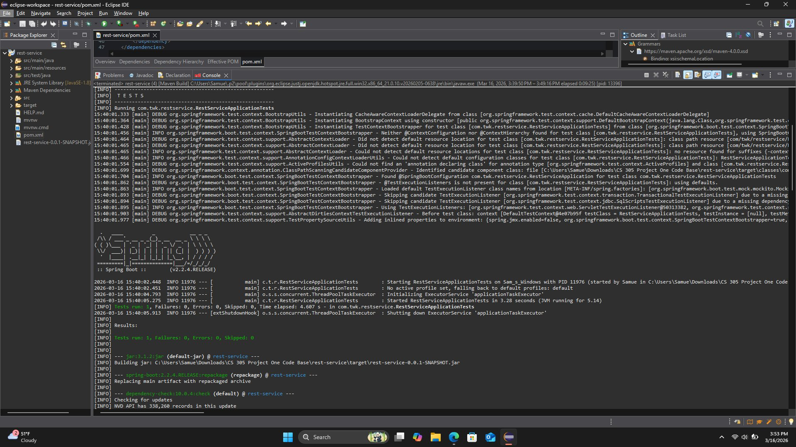

Figure 2: Eclipse Console — BUILD SUCCESS (Total time: 09:19 min)
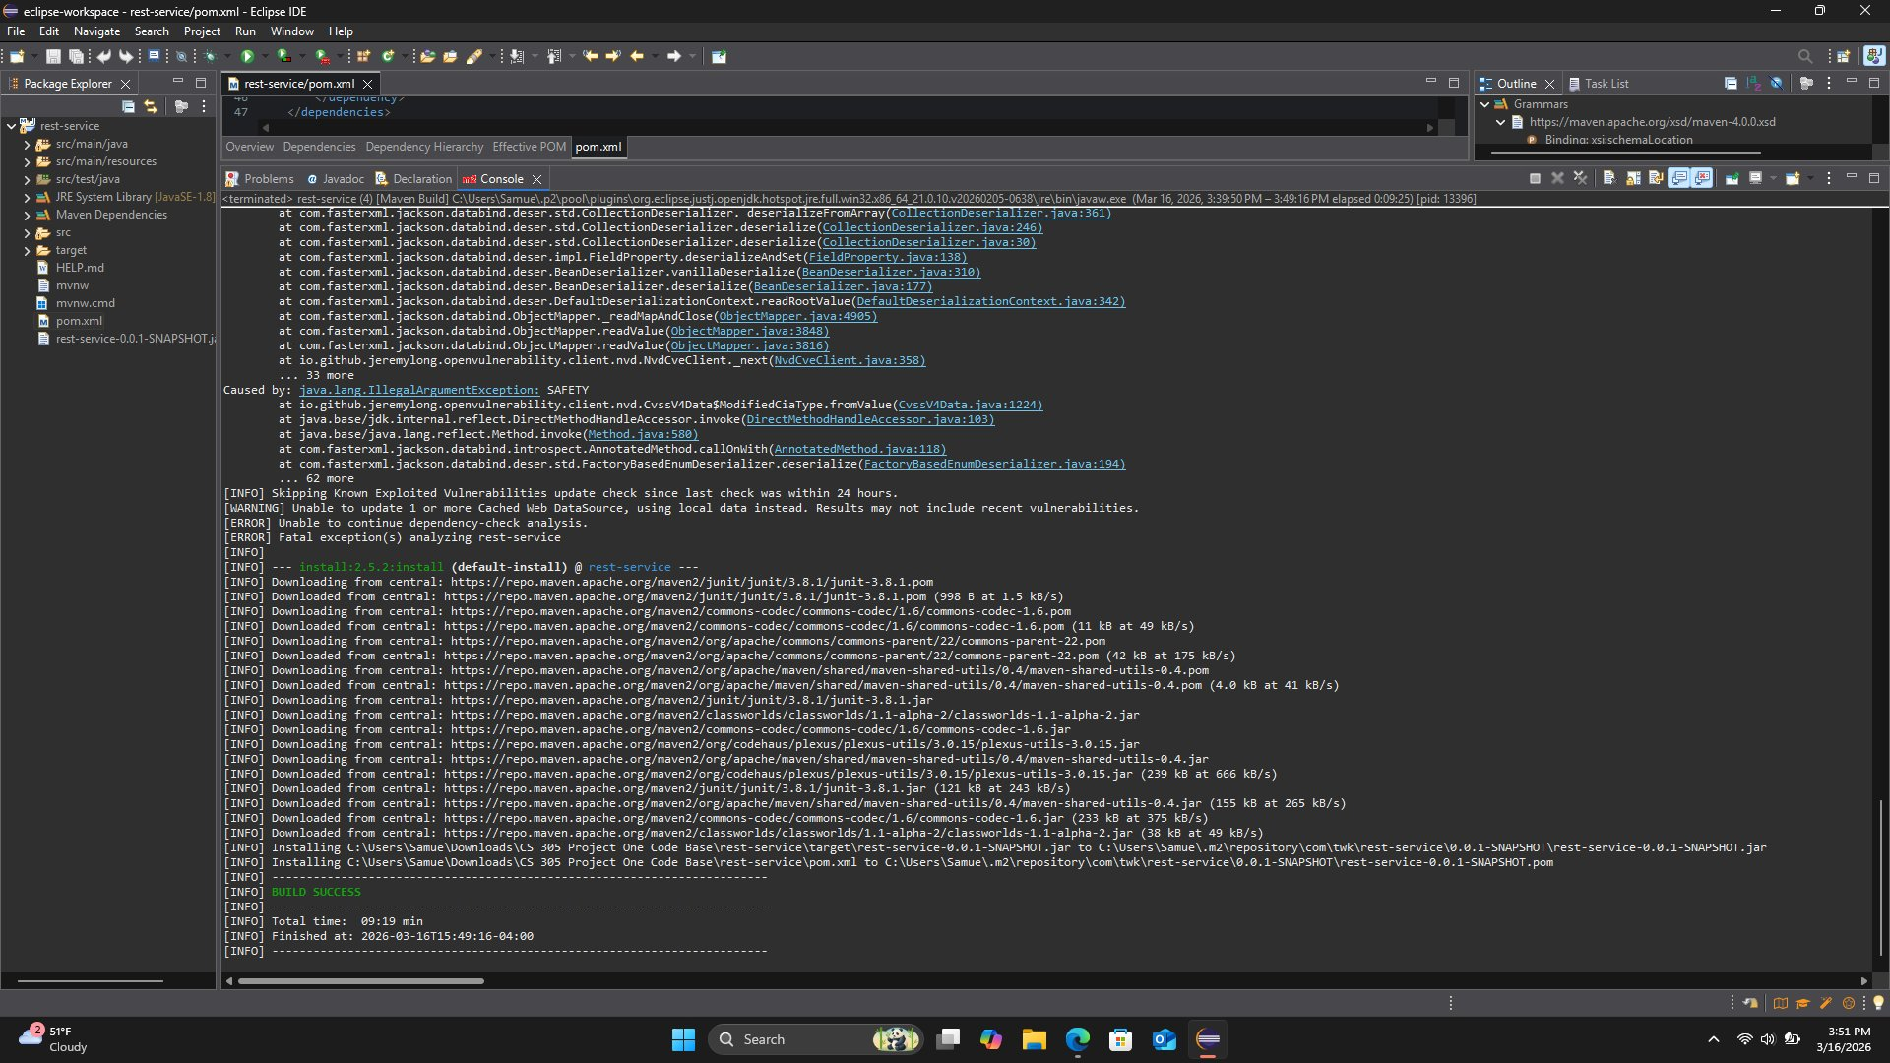

Figure 3: Eclipse Console — NVD CVE database download progress (338,260 records)
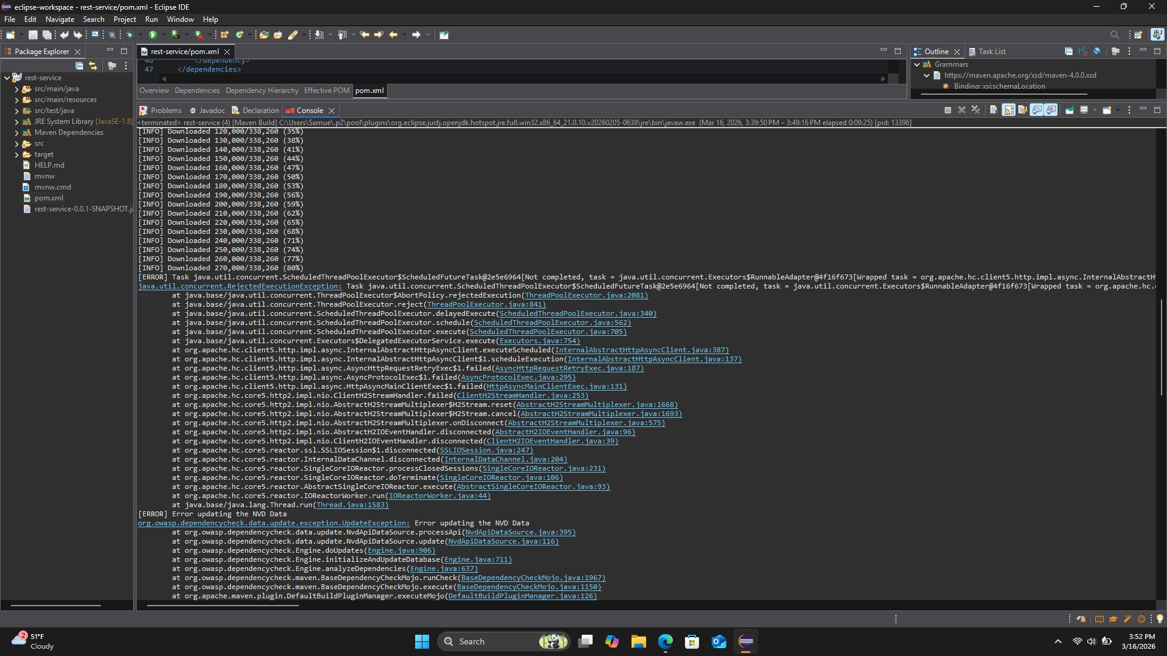

Figure 4: Eclipse Console — NVD update execution details
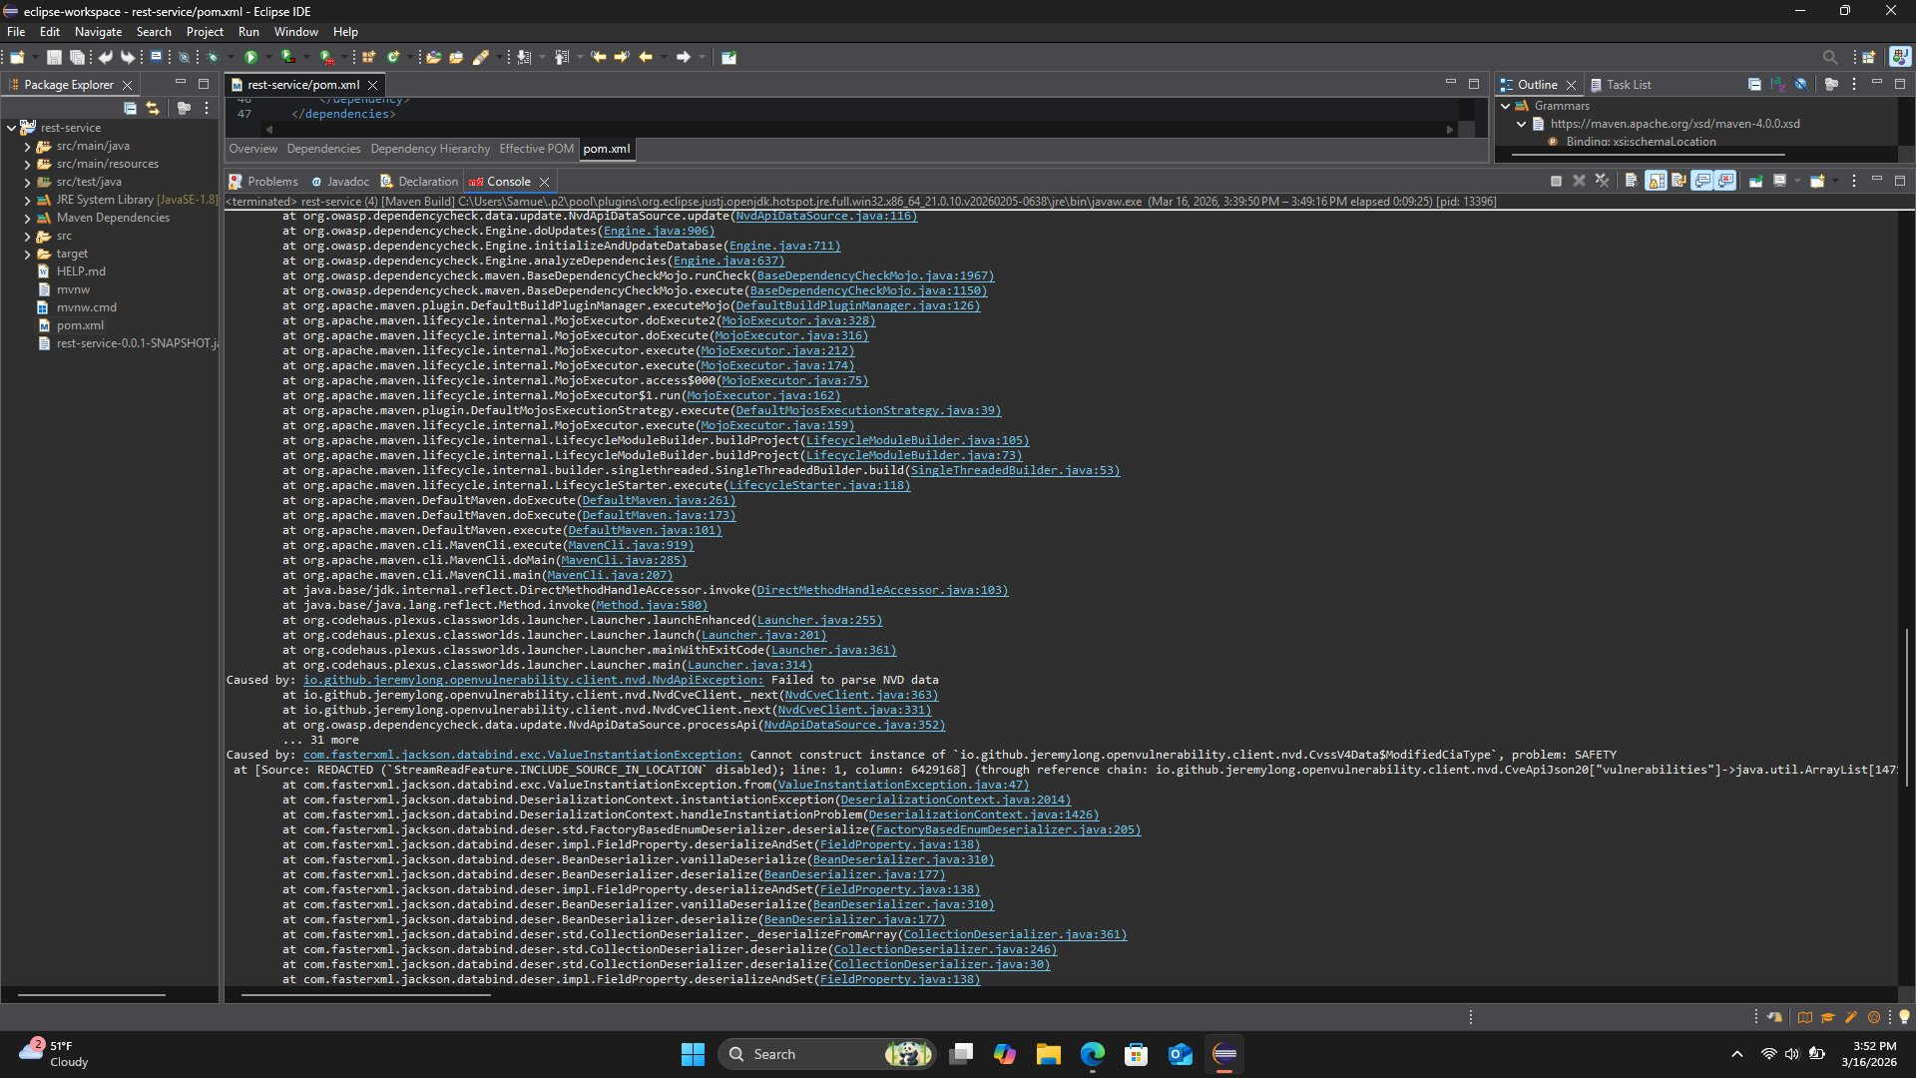

Dependency | CVE Code(s) | Severity | Description from Report | Recommended Fix | Attribution (from CVE References)
bcprov-jdk15on-1.46.jar  (Bouncy Castle) | CVE-2020-15522  CVE-2020-26939  CVE-2018-1000613  CVE-2016-1000338 | HIGH /  CRITICAL | Bouncy Castle 1.46 has serious cryptographic vulnerabilities. CVE-2020-15522 is a timing side-channel attack on ECDSA that could let an attacker recover a private key. CVE-2020-26939 is a CBC padding oracle vulnerability. Both were identified by the Bouncy Castle security team and published in the NVD. | Upgrade to Bouncy Castle 1.77 or newer. The References section of CVE-2020-15522 links to the Bouncy Castle release page showing version 1.66 was the first patched release. Review all cryptographic operations in the project. | NVD: https://nvd.nist.gov/vuln/detail/CVE-2020-15522  Fix ref: https://www.bouncycastle.org/latest_releases.html  GitHub: https://github.com/bcgit/bc-java/releases
spring-boot-2.2.4.RELEASE  (Spring Framework  + embedded Tomcat) | CVE-2022-22965  (Spring4Shell)  CVE-2021-22096  CVE-2020-5421  CVE-2023-46589 | CRITICAL /  HIGH | Spring Boot 2.2.4 bundles outdated Spring Framework and Tomcat. CVE-2022-22965 (Spring4Shell) allows unauthenticated remote code execution on JDK 9+ via class loader abuse. This was widely exploited in the wild in 2022 shortly after disclosure. | Upgrade Spring Boot to latest 3.2.x. The References section of CVE-2022-22965 links to the official Spring security advisory confirming the minimum patched versions. Java 17+ will be required. | NVD: https://nvd.nist.gov/vuln/detail/CVE-2022-22965  Spring advisory: https://spring.io/security/cve-2022-22965  VMware: https://tanzu.vmware.com/security/cve-2022-22965
json-path  (version not pinned) | CVE-2023-51074 | MEDIUM | Versions of json-path before 2.9.0 are vulnerable to a stack overflow caused by deeply nested JSON path expressions, which could crash the application. Reported by a security researcher and documented in the NVD. | Pin json-path to version 2.9.0 or later in pom.xml. The References section of CVE-2023-51074 links to the GitHub pull request that introduced the fix. | NVD: https://nvd.nist.gov/vuln/detail/CVE-2023-51074  GitHub fix: https://github.com/json-path/JsonPath/pull/973  Release: https://github.com/json-path/JsonPath/releases/tag/json-path-2.9.0
Embedded Tomcat  (via Spring Boot  2.2.4) | CVE-2023-28708  CVE-2023-46589 | HIGH | The Tomcat version bundled with Spring Boot 2.2.4 has information disclosure via incomplete PUT requests and HTTP request smuggling. Both were identified by the Apache Tomcat security team. | Upgrading Spring Boot to 3.2.x automatically includes Tomcat 10.1.x with both issues fixed. The References section of each CVE links to the Apache Tomcat security announcements page. | NVD CVE-2023-28708: https://nvd.nist.gov/vuln/detail/CVE-2023-28708  NVD CVE-2023-46589: https://nvd.nist.gov/vuln/detail/CVE-2023-46589  Apache: https://tomcat.apache.org/security-10.html

5. Mitigation Plan
Interpret the results from the manual review and static testing report. Then identify the steps to mitigate the identified security vulnerabilities for Artemis Financial’s software application.

Based on both the manual review and the dependency-check results, I put together the following action plan. I organized everything by priority level so the development team knows what to tackle first. The critical items are ones where an attacker could do serious damage right now if the application were deployed as-is.

Priority | Issue | File(s) | How to Fix It
CRITICAL | Hardcoded database credentials | DocData.java | Remove the hardcoded root credentials immediately. Move database connection details to environment variables or a secrets manager like HashiCorp Vault. Create a dedicated database user with only the permissions the application actually needs.
CRITICAL | Spring4Shell — Spring Boot 2.2.4 | pom.xml | Upgrade the Spring Boot parent to the latest 3.2.x release. This automatically upgrades Spring Framework and embedded Tomcat to patched versions. The project will also need to move to Java 17 or higher. The official Spring security advisory (CVE-2022-22965 References) confirms the minimum safe versions.
CRITICAL | Bouncy Castle 1.46 cryptographic CVEs | pom.xml | Update bcprov-jdk15on to version 1.77 or newer. The Bouncy Castle release page linked in the CVE-2020-15522 References section confirms 1.66 was the first patched release. After upgrading, audit all cryptographic operations in the codebase.
HIGH | No authentication on REST endpoints | CRUDController.java | Add Spring Security and configure JWT Bearer Token or OAuth 2.0 authentication on all endpoints. Add role-based access control so users can only access what they are authorized to see.
HIGH | SQL injection in read_document() | DocData.java | Rewrite read_document() to use PreparedStatement with parameterized queries. Even better, migrate to Spring Data JPA which handles safe parameterization automatically and reduces the chance of this kind of mistake.
HIGH | No SSL on database connection | DocData.java | Add ?useSSL=true&requireSSL=true to the JDBC URL. Configure the database server to require TLS. Store certificate and keystore credentials in a secrets manager, never in source code.
HIGH | Stack trace exposed in logs | DocData.java | Replace e.printStackTrace() with SLF4J logging: logger.error("message", e). Spring Boot already includes SLF4J. Configure log output to go to a secure log file at ERROR level only, never to the console in production.
HIGH | 200 MB unrestricted file uploads | application.properties | Lower max-file-size to a reasonable limit like 10 MB. Add file type validation using MIME type checking to reject unexpected file formats. Add rate limiting on the upload endpoint to prevent abuse.
MEDIUM | No input validation on request params | CRUDController.java | Add @NotBlank, @Size, and @Pattern annotations to all request parameters. Create a @ControllerAdvice global exception handler that returns clean, structured error responses without leaking internal details.
MEDIUM | account_balance is package-private | customer.java | Declare account_balance as private. Add a getAccountBalance() getter and update the deposit() method to reject negative values and validate the input before updating the balance.
MEDIUM | Integer overflow in deposit() | customer.java | Replace the raw addition with Math.addExact(account_balance, a) which throws an ArithmeticException on overflow instead of silently corrupting the balance. Consider using long instead of int for financial values.
LOW | Unimplemented stub methods | myDateTime.java | Either implement retrieveDateTime() and setMyDateTime() with real logic, or remove the class entirely if it is not used. Shipping empty stubs causes confusing silent failures at runtime.
LOW | Class naming conventions violated | customer.java,  myDateTime.java | Rename customer to Customer and myDateTime to MyDateTime to follow standard Java naming conventions. This prevents class-loading issues on case-sensitive Linux file systems and improves code readability.
LOW | Dependency-Check plugin outdated | pom.xml | The plugin was updated to 10.0.4 for this assessment. Keep it at the latest version going forward so every build scans against the most current CVE data from the NVD.

Priority | Issue | File(s) | How to Fix It
CRITICAL | Hardcoded database credentials | DocData.java | Remove the username and password from the source code immediately. Store them in environment variables or use a secrets management tool. Use a database account that only has the minimum permissions it needs, not root.
CRITICAL | Spring Boot 2.2.4 and Spring4Shell | pom.xml | Update the Spring Boot parent version to the latest 3.2.x release. This also updates Spring Framework and Tomcat automatically. The project Java version will need to be updated to 17 or higher to support Spring Boot 3.
CRITICAL | Bouncy Castle 1.46 cryptographic vulnerabilities | pom.xml | Update the bcprov-jdk15on dependency to version 1.77 or newer. After updating, review all the places in the code that use Bouncy Castle to make sure the cryptographic algorithms being used are still considered secure.
HIGH | No authentication on REST endpoints | CRUDController.java | Add Spring Security to the project and configure it to require authentication for all endpoints. JWT tokens or OAuth 2.0 would be appropriate for an API. Each endpoint should also check that the caller has permission to perform that specific action.
HIGH | SQL injection risk in read_document() | DocData.java | Rewrite read_document() to use PreparedStatement with parameterized queries instead of building SQL strings manually. An even better option would be to use Spring Data JPA which handles this safely by default.
HIGH | No SSL on database connection | DocData.java | Add useSSL=true and requireSSL=true to the JDBC connection string. The database server should also be configured to only allow encrypted connections. The SSL certificate and keystore credentials should be stored securely, not in source code.
HIGH | Stack trace printed to console | DocData.java | Replace e.printStackTrace() with proper logging using SLF4J, which is already included with Spring Boot. Use logger.error() to log the exception to a file at the ERROR level. Never print internal error details anywhere a user or attacker could see them.
HIGH | 200 MB unrestricted file uploads | application.properties | Lower max-file-size to something reasonable for the actual use case, such as 10 MB. Add file type validation to reject files that are not the expected format. Consider adding rate limiting to the upload endpoint to prevent abuse.
MEDIUM | No input validation on request parameters | CRUDController.java | Add Spring Validation annotations like @NotBlank, @Size, and @Pattern to the request parameters. Create a global exception handler using @ControllerAdvice that returns a clean error message to the user without leaking any internal details.
MEDIUM | account_balance is package-private | customer.java | Declare account_balance as private. Add a getAccountBalance() method for reading it and a validated deposit method for updating it. The deposit method should reject negative values.
MEDIUM | Integer overflow in deposit() | customer.java | Replace the addition with Math.addExact(account_balance, a) which will throw an exception instead of silently overflowing. Also consider using long instead of int for any field that holds a financial amount.
LOW | Empty stub methods | myDateTime.java | Either complete the implementation of retrieveDateTime() and setMyDateTime() so they return real values, or remove the class entirely if it is not actually used by the application.
LOW | Class naming convention violations | customer.java, myDateTime.java | Rename customer to Customer and myDateTime to MyDateTime to follow standard Java naming conventions. This makes the code easier to read and prevents potential problems on case-sensitive file systems like Linux.
LOW | Dependency-Check plugin is outdated (5.3.0) | pom.xml | Update the dependency-check-maven plugin version to 9.0.7 or the latest available version. The newer version has access to a more complete and current set of CVE data from the NVD.

